1. **CODE**

See attachments.

1. **PNL GRAPH**

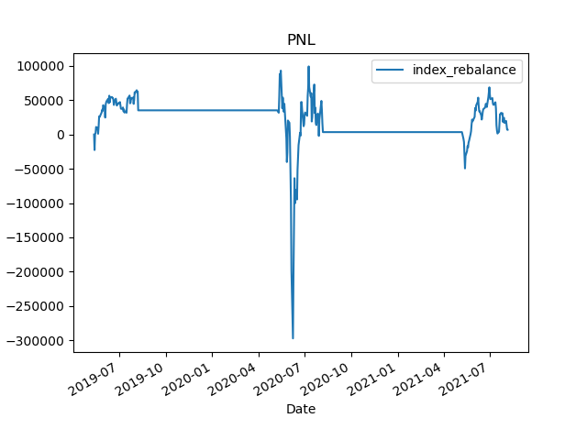

1. **SUMMARY STATISTICS**

|  |  |
| --- | --- |
| **Statistics** | **value** |
| **IR** | **-0.88** |
| **Sharpe Ratio** | **-0.31** |
| **BETA** | **-0.068** |
| **Max Drawdown** | **390642** |
| **VaR (0.99)** | **1903619** |
| **ETL (0.99)** | **1826789** |
| **Annualized Ror** | **0.002** |